NEW ENGLAND INSTITUTE OF TECHNOLOGY

Information Technology Department

Quest #4

Data Structures and Algorithms (SE 394)
Due: Week #4



Joshua Legoff

Developer

10/27/2015

Date

George Saban

Instructor
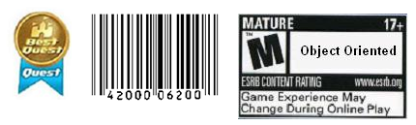

Requirements:

Instructions:
- According to some research, industry values documentation, and excellent written and oral communication skills. The purpose of this part of the class is to encourage you to gain these skills.
- Backup your work to your USB drive for this material may come out as part of your examination.
- Make a copy of this entire document and add your work into it.
- Submit to Blackboard at the same link where you got this document.
- Points will be a deducted if submitted on the wrong place, or if these instructions are not followed.
- [You can earn a maximum of 40 points for this lab. Refer to the syllabus for late point deductions.]

Problem Statement

Part I: | – this will reinforce your understanding of Stacks.

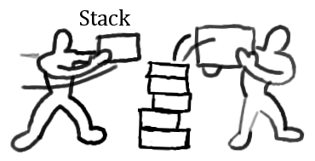
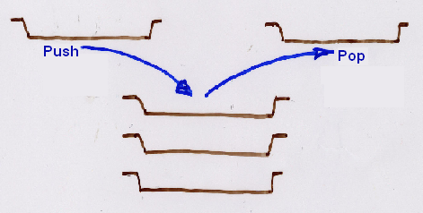

Create your own problem that can be elegantly solved using a stack. In other words, come up with a problem that is solvable using a stack. Here’s the requirement:
  - In 200 words or more, write the detailed description of the problem. Note that you have to write a minimum of 200 words describing what this problem is all about.
  - And then, solve the problem by applying a stack into your solution. Implement your solution using the Java language.

– OR – Alternatively, if you could not come up with your own problem then you may solve the problem below.

Create a stack of Sound objects. Where Sound objects include attributes sound name and sound length. In the driver program push five sounds and pop two, and then print the top element to prove that the top element is the correct element.

Hint: consider the stack exercise we did in Blackboard. This quest and the next one are very short quests. Instead of combining the quests into one it is split so you can earn more points.

Code Development:
package Quest4;

public class Sound {

private String soundName;
private String soundLength;

public Sound(){

}

public String getSoundName() {
return soundName;
}

public void setSoundName(String soundName) {
this.soundName = soundName;
}

public String getSoundLength() {
return soundLength;
}

public void setSoundLength(String soundLength) {
this.soundLength = soundLength;
}

}

package Quest4;

public class SoundStack {
private java.util.LinkedList<Sound> list = new java.util.LinkedList<Sound>();

public boolean isEmpty(){
return list.isEmpty();
}

public Object topEl(){
if(isEmpty())
throw new java.util.EmptyStackException();
return list.getLast();
}

public Object pop(){
if(isEmpty())
throw new java.util.EmptyStackException();
return list.removeLast();
}

public void push(Sound el){
list.addLast(el);
}
public String toSting(){
return list.toString();
}

}

package Quest4;

public class Driver {

public static void main(String[] args) {
// TODO Auto-generated method stub
Sound sound = new Sound();
sound.setSoundName("Bang");
sound.setSoundLength("00:00:01");
Sound sound2 = new Sound();
sound2.setSoundName("Boom");
sound2.setSoundLength("00:00:02");
Sound sound3 = new Sound();
sound3.setSoundName("Bonk");
sound3.setSoundLength("00:00:03");

SoundStack soundStack = new SoundStack();
soundStack.push(sound);
soundStack.push(sound2);
soundStack.push(sound3);
System.out.println(((Sound)soundStack.topEl()).getSoundName().toString() + " is "
+ ((Sound)soundStack.topEl()).getSoundLength().toString() + " long.");
soundStack.pop();
System.out.println(((Sound)soundStack.topEl()).getSoundName().toString() + " is "
+ ((Sound)soundStack.topEl()).getSoundLength().toString() + " long.");
}

}

Testing:
What is testing for? Every program you wrote, you are responsible for unit testing it. The first thing to do, once you have a program that “basically works”, is to try to break it. Try to feed your program input(s) in the hope of getting it to misbehave. By “hope” means that the challenge here is to find as many errors as possible, so that you can fix the errors before anybody else finds them. If you go into this exercise with the attitude that “my program works, and I don’t make errors!”, then you won’t find many bugs, and you will feel bad when you do find one or when someone finds one. You’d be playing head games with yourself! The right attitude when testing is, “I’ll break it! I’m smarter than any program--even my own!”
Feed (or try) a few such “problematic” inputs to your program and try to figure out in how many ways you can get it to misbehave. Can you get the program to crash? Testing is a very important part of game development, and can actually be fun. You may input data that is not “sensible”. A program ideally catches all errors, not just the sensible ones--this will make your program resilient against “strange input.”
As a goal, you would like the test to exercise every statement in your program, at least once. Test both positive and negative scenario. One example of positive testing is--if you have an input that requires an integer value, would it work if you give it the numeral 7? Moreover, as an example of negative testing: what happens if you give the previous program a string input of “seven” (instead of the numerical 7)? Identify if your test results are “Passed” or “Failed”. Use the table below, and add at least five test cases of your own!
[Type at least 5 test cases and what was the result? Did the result pass or fail? Do a negative test case too!]
Test # | Test Description | Result  (Passed/Failed)
1 | Pushed 3 Sound objects into stack and retrieved top | Passed
2 | Pushed Object into Sound stack | Failed
3 | Push Sound object into stack and pulled top sound object after. | Passed
4 | Pushed String into stack | Failed
5 | Push Integer into stack | Failed
 | Add as many rows as needed.

Production Deployment:
[Paste all your own final screens in this section.] Make sure your output screen shot is readable, magnify if necessary so the instructor can easily read it. A sample magnified output is shown below; replace this with your own.
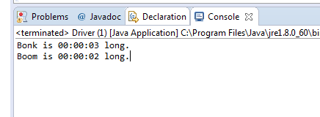

GRADING RUBRIC
Grading Criteria | 3  Exceeds  Excellent  Epic Wow | 2  Meets  Satisfactory  O.K. | 1  Partially Meets  Below Expectations  Not Yet | 0  Does Not Meet  Unacceptable  Fail
Coding | +10-Code is excellent, comments are added, and program works. | +8-Code is O.K., and program works. | +6-Code works, but still needs improvement. | Unfortunately, no coding.
Output | +10-Outputs are correct, and provided additional output cases. | +8-Output meets requirement and is readable. | +6-There is output, but not readable, and/or needs improvement. | Unfortunately, no output.
Testing | +10-Test cases were excellent, and provided more test cases than required. | +8-Provided valid tests, and meets minimum test case requirements. | +6-Test needs improvement, did not make sense, and did not meet minimum test case requirements. | Unfortunately, no testing.
Documentation | +10-Excellent documentation. | +8-Documentation meets requirements. | +6-Documentation has misspelling, or syntax issues, or not clear, or needs improvement. | Unfortunately, no documentation.
Late | Excellent, you submitted it before the deadline. | -5, for submitting after the deadline. | -10, for submitting several weeks after the deadline. | -15, unfortunately, for submitting very late.

